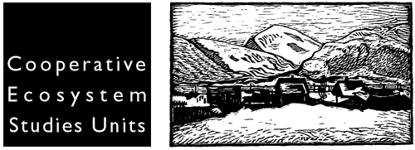

PNW CESU Project Summary Form

Project Title: | Location (s) of Project Activity:
Cooperative Agreement No.: HAA003D00  Agency Task Agreement No.: (assigned by agency) | University Partner(s):  Federal Partner (s):  BUREAU OF LAND MANAGEMENT
Effective Dates: | Student Involvement:  Yes ______ No _______
Type of Project:  Research ______ Technical Assistance _______  Education _____ | Project Discipline(s)/Fields:  Biological __________ Cultural _________  Physical ___________ Interdisciplinary________  Social __________
Key Words: | Funding Amount:
Principal Investigator(s): (name address, phone, email) | Federal Agency Project Technical Representative(s) (name, address, phone, email)

Project Abstract:

Project Products/Deliverables with Completion Dates: (technical report, journal article, workshop, etc)

Email completed form to: pnwcesu@u.washington.edu (preferred) or mail/fax to: Joel Siderius Program Assistant, PNW CESU, College of Forest Resources, Box 352100, University of Washington, Seattle Washington 98195-2100. Fax: 206-685-0790.

